**Request for Quotation (RFQ)**

**Document**

**For the Provision of**

**Easy Finance (i.e. eApplication)**

Amendent log:

|  |  |  |  |
| --- | --- | --- | --- |
| Version | date | author | Changes |
| 0.1 | 2018-09-09 | Bai Tao | nitial version |
| 0.2 | 2018-09-17 | JiChao | update sla |
| 1.0 | 2018-10-19 | jichao | update user stories |
| 1.1 | 2018-10-26 | Bai Tao | Updated requirements for Agile |

# Contents

SECTION 1: TENDER INSTRUCTIONS 3

SECTION 2: SPECIFICATION 8

SECTION 3: SERVICE AGREEMENT 18

# Section 1: TENDER INSTRUCTIONS

|  |
| --- |
| **VENDOR should read all the instructions carefully before responding. Failure to comply with these requirements may result in the rejection of a Tender response.** |

## BMW AFC overview

BMW Automotive Finance (China) Co., Ltd. (hereinafter referred to as “BMW AFC”), founded in 2010, is a joint venture between the BMW AG and BMW Brilliance. BMW is committed to providing customers with intimate financial products and high-end, professional services. BMW finance will provide "one-stop" Car Buy-ing and loan services to customers, allow customers to enjoy financial products but also to experience BMW Automotive financial service.

## Confidentiality/Copyright

This Request for Quotation (RFQ) document and its associated annexes and schedules are subject to the laws of copyright and must not be reproduced in whole or in part without the prior written consent of BMW AFC. Furthermore, all information contained within the document, its associated schedules and any electronic attachments are given in strict confidence.

This RFQ should not be divulged to any third party without the prior written authority of BMW AFC. If the VENDOR provides information to a notified third party for the purpose of receiving quotations for parts of the products or services not covered in house, the VENDOR is responsible for ensuring that his subcontractor also treats this information as “Commercial in Confidence.”

All information submitted by VENDORS in response to this Invitation to tender will be treated as “Commercial in Confidence.”

This RFQ document remains the sole property of BMW AFC and should be returned with the VENDOR’s Tender response.

## Use of Trademarks

The BMW AFC trademarks should not be re-produced anywhere in your RFQ response.

## General Instructions

* 1. All information in this Request for Quotation is provided in good faith and represents BMW AFC’s view of the service BMW AFC requires. However, BMW AFC relies on the VENDORS to inform BMW AFC about the most efficient and cost-effective methods of delivering these services. BMW AFC therefore welcomes questions or advice on any area of BMW AFC’s specification. It will be at BMW AFC’s discretion as to whether replies to particular queries are communicated to other respondents. BMW AFC reserves the right to amend the specification at any time during the Tender process.

4.2 Detailed terms and conditions of business will be agreed before contracts are awarded.

4.3 As a Tender from vendor, provides services for competing brands, including Mercedes Benz, Audi, Volvo and Lexus at the same time, (BMW AFC reserves the right to add other competing brands to this list): Please disclose the names of your automotive customers and describe the services rendered, respectively, in your Tender. Please let us know how you can protect BMW AFC customer data and how you ensure the service/manpower/software/hardware, etc is separated absolutely from different clients.

4.4 The VENDOR shall procure and maintain all licenses, permits, and authorizations required by law to perform the Service required, including but not limited to payment certification issued by PBOC or other required certification or licenses required by government authorities or BMW AFC. And final selected vendor shall also ensure all required and committed certificates and licenses to be valid during the whole term of contract.

4.5 The BMW AFC will only establish contract relationship with final selected vendor, and such vendor shall be fully liable for any loss arisen from itself and its assigned third-party service provider.

4.6 Tender costs should be fixed for the **3 (THREE) YEARS** duration of the contract, which will commence on 1st Jan, 2019 and conclude on 31th Dec, 2021.

4.7 Tenders may be rejected if the complete information requested is not given at the time of Tendering. Supporting literature may accompany the Tender, but answers to the questionnaire should be in the Tender response itself, with reference to accompanying literature kept to a minimum.

4.8 BMW AFC reserves the right to accept or reject any Tender and to annul the Tender process and reject all Tenders at any time prior to the award of contract without incurring any liability to the affected VENDORS.

4.9 BMW AFC will not be liable for any costs incurred by VENDORS in the preparation and submission of their Tender nor for costs that arise out of any site visits or presentations requested by BMW AFC.

4.10 BMW AFC reserves the right to award all or part of the services to the VENDOR and reserves right to distribute the award on a regional basis.

4.11 BMW AFC requests full onsite support during project execution on time setup, all the quotation and related activities should consider for this, and resources for onsite support should qualified for Agile team requirements, in case of any team number who is not qualified, BMＷ AFC reserve the right to request to change resource unitl resource is qualified, and anything impact projecte delivery the because of this should be bear by Supplier.

4.12 Requirements briefing within RFQ documentation are only for general working scope for cost and effort estimation, BMW AFC reserves the right to change and modify and expand each user stories and Epics supplier cannot based on this as final SOW.

4.13 Contract Scope not only include one time setup for Easy Finance application operaition maintainance, but also include handover existing and also future application Applcation Operaiton and Maintenance for digital products and systems please reference details scope in below.

4.14 BMW AFC requests to have Face recognition, ORC scanning, CA Authenticaiton etc. in e-authentication in case supplier doesn’t own this technology, supplier request to have sub-contracts to market suppliers (Put priority to suppliers which recommended by BMW ) and inform BMW to reach BMW requirements and providng the solution as a pakcage. And the cost should be fill in final quotation template as license cost with BMW agreements.

4.15 BMW AFC request supplier to have rich Agile working experiances and full Agile development team onsite through Dev-Ops model and Micro services to complete project execution.

Full automention process during project execution especially for

* Automated testing reach 80% above.

- Continuous integration, continuous deployment, Continuous delivery.

- Source code management

- Auto code quality control(e.g. SonarQube)

- Full code management within BMW tool chain according to BMW guidelines

Iteration circle less then one month WITH good quality. .

BMW Agile Toochain landscape.

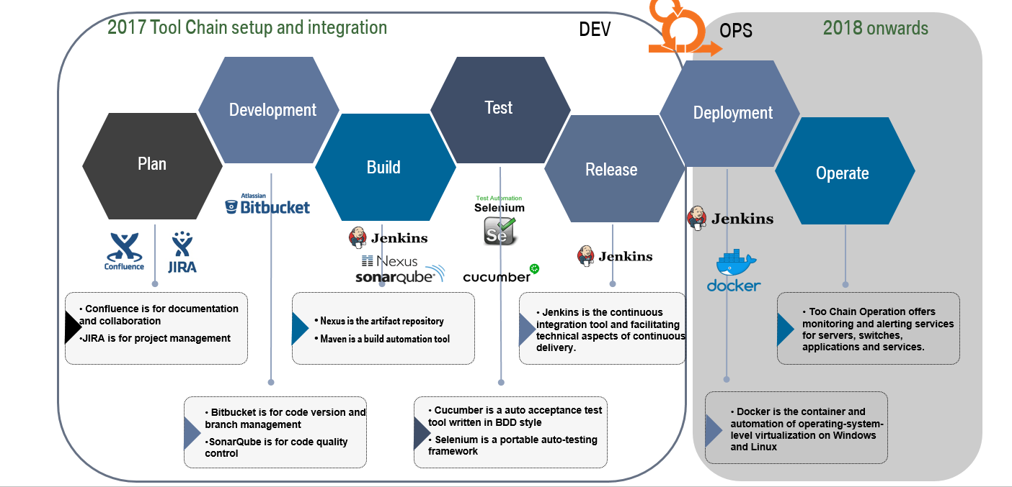

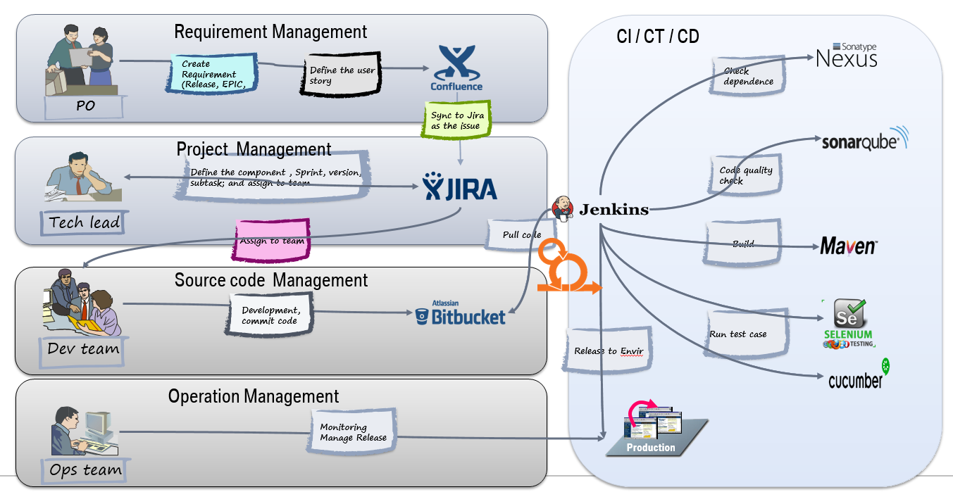

4.16 BMW AFC requests working scope also including UI and UX design and development.

4.17 Supplier should commit on agreed timeline and delivery scope, in case of any exception cause by supplier impact project delivery timeline, BMW AFC will depends on the impact to make the penalty( from 5% to 30%) of ontime setup cost.

4.18 All the sub-contracts to purchase products (OCR scanning, Face recognition, CA authentication) should satify with BMW requirements.

- On premise deployment is mandatory.

- (No sperate hardware) software solution is recommend.

- BMW recommended supplier(Will shared with the RFQ documentation) should be take into consideration by priority, but if other products can also satifiy BMW requirements, supplier should inform BMW and get alignment.

- The contract between E-application supplier and products (OCR scanning, Face recognition, CA authentication) supplier should clearly mention this license should can be used by BMW project and share with BMW regarding the contract details.

## Tender Response

5.1 Please submit a response to this Tender document by **16th Nov, 2018**. If your Tender document is not received by the date above, your Tender submission will be disregarded.

Please send your Tender the attention to:

|  |  |
| --- | --- |
| BMW AFC, Digitalization  **Dee Wu**  Dee.Wu@bmw.com | BMW AFC, Digitalization  **Befelein Maximilian**  Maximilian.Befelein@bmw.de |
| BMW AFC, Purchasing  **James Xie**  Ke.Xie@bmw.com | BMW AFC, IT  **Tao Bai**  Tao.bai@bmw.com |

5.2 BMW AFC still retain right to release the updates and clarifications as a supplement. With a mutual agreement, VENDOR should be able to update your proposal or quotation accordingly, and turn in Tender submission timely.

5.3 All questions during the Tender process must be sent to BMW AFC **in one single document** to the individuals noted above. This document should include a versioning for all updates. This document will also be used to provide the respective answers from BMW AFC. For all other questions via email, phone or other channels BMW AFC cannot guarantee that the answer is binding.

5.4 We understand vendor may need to submit supplementary response during the tender process, and if the content of two response conflict, then the latter one shall prevail.

5.5 All the cost should be proper documented into the Quotation template, BMW will not pay addtiona cost which is outside of Quotaiton template besides change of request.

## Selection Criteria & Tender Timeline

* 1. BMW AFC will make the final VENDOR selection based on the following criteria:
     + The level to which the proposed response meets the business and the commercial requirements.
     + The degree to which the proposed response meet acceptable levels of performance.
     + The VENDOR's capability to fully support its proposal.
     + The competitiveness of the price quoted for all services.
     + The acceptability of the VENDOR's legal and financial standing.
     + Compliance to BMW AFC’s Terms and Conditions.
     + Other value-added services can be provided.
     + The appropriate emergency response plan and business continuity plan, also necessary fines and penalties.
     + The appropriate transition plan to guarantee enough time for seamless transition when the contract comes to the end of the term.

6.2 Detailed timeline (please be noted below timeline is still flexible subject to BMW AFC adjustment)

|  |  |
| --- | --- |
| **Project milestone** | **Time** |
| Biz & IT RFQ Release | Nov 5th 2018 |
| Bidding Briefing Meeting & Supplier Q&A | Nov 6th 2018 |
| Vendor the 1st draft Proposal to BMW | Nov 19th 2018 |
| BMW feedback to 1st draft proposal | Nov 21st 2018 |
| Vendor Presentation with updated version | Nov 22th 2018 |
| Q&A & on-site visit (if needed) | NA |
| Vendor provide the final proposal and quotation | Nov 23th 2018 |
| Evaluation + TSR | Dec 7th 2018 |
| Supplier Contract Sign off | Dec 31st 2018 |

## Notification

BMW AFC will notify acceptance in writing to the successful VENDOR. After the contract is agreed, BMW AFC will notify each unsuccessful VENDOR as soon as is reasonably practicable. BMW AFC reserves the right to nominate VENDOR for all or just specific elements of this Tender.

## 8. Tender Feedback Requirement

Tender feedback must be received by BMW AFC on or before **19th Nov, 2018, 03:00 PM.**

Tender including all attached documents must be in English. Chinese version is optional. A Template Tender Feedback is available at the end of this section. The same Template must be used by each applicant with the following criteria:

Tender including all attached documents must be in English.

Documents must be in PDF or MS WORD 2007 or 2010 format.

Sample reports must be in MS Excel 2007 or 2010 format.

Quotation must be strictly prepared in BMW AFC template.

Any plan timing must be in MS Excel or MS Project format.

Tender should definitely conform to the Tender Feedback.

8.3 Tender feedback should include:

**Company profile**

History

Licenses (Please list all the mandatory and non-mandatory licenses and certificates you have obtained related to current project.)

Ownership

Reference projects (Client, description, solution, size of the operation, number of communications per month, reference contacts)

Operation KPIs and performance

Experience of providing similar to other Automotive or non-Automotive groups.

**Proposed solution**

Communications matrix to BMW AFC

Named person with profiles and experience

Understanding of BMW AFC Tendering requirements and proposal (organization, process, governance, etc)

Proposed organization structure supporting BMW AFC business.

Respectively proposed processes including but not limited to IT, system support, business continuity plan, operational support and transition plan.

Respectively proposed KPIs including but not limited to system response time, recovery time and reporting time.

Respectively proposed KPIs including OCR and face recognization accurancy and response time.

Respectively proposed KPIs including NCIIC interface to do photo comparison.

Respectively proposed KPIs including CA authentication.

Proposed customer notification and communication processes.

Daily maximum volume of request processed.

Data store plan for BMW AFC Easy Finance and any data which happened in the user journey.

Respectively proposed business support organization account for BMW AFC.

Respectively proposed IT solution and project management team which can integrate with BMW AFC system.

Respectively proposed security solution especially BMW AFC customer data protection.

Account receivable monitoring solutions (Real-time reporting and historical reports).

Quality controls and system availability assurance.

Urgent regulation alert mechanism.

Price

Providing details and breakdown of quotation, refer to the quotation template.

Other available services offered

Description

Access to additional valuable information about BMW AFC customers.

Pricing examples if applicable

IT SYSTEM SUPPORT

Supplier provide delegate IT resource during project period and after go-live

SLA needs to be provided and sign off by both BMW AFC IT and business.

Emergency solution to be provided to ensure daily business operation will not be impacted by any system issues.

Level Support

SLA needs to be provided and sign off by both BMW AFC IT and business.

Emergency solution to be provided to endure daily business operation will not be impacted by any system issues.

Data security

A clear infrastructure and architecture diagram with necessary information description is highly recommended.

Deviation from the attached “Tender Feedback” can have a negative effect on the evaluation of a tender.

In the “Cost Criteria” of “Tender Feedback”, please specify the cost between each project milestone and the respective daily rate. In the “Tender Structure”, please also specify the rate and cost for future case by case maintenance.



## 9. Sourcing Scenarios

9.1 BMW AFC is evaluating the following scenarios for BMW AFC Easy Finance project. And the project would be run by agile methodology.

9.3 For future scenario, BMW AFC may at its own discretion to decide how much more user stories will be additional. All change request related requirement for this project will be included in this project.

9.4 Sub-Provider Management

Supplier may subcontract or delegate any of its obligations with confirmation by BMW AFC in advance. Supplier shall always be responsible for all obligations performed by subcontractors to the same extent as if such obligations were performed by Supplier.

# Section 2: Specification

## Overview

Currently, for BMW AFC China, customer can only apply loan in dealership and the information input and documents uploads are done by F&I in DFE. There is no platform to support customer apply loan by themselves via mobile devices. Meanwhile, customer can’t timely view application status by themselves.

Easy Finance project aims to develop a platform to support customer apply for BMW Financial services by themselves via mbile devices.

This Tender document outlines the requirements for the provision of BMW AFC for BMW AFC China.

Rationale for project:

* Open a new applicaiton channel to BMW AFC customers
* Decrease customer effort and improve customer experience
* Support sales to increase the application volumes
* Better control operational cost by Innovation & Digitalization

## Requirement

### Easy Finance Requirements: Epics and User Stories

**\* the requirements below are only for reference, detail requirements may have changes and updates during requirement clarification phase and development phase.**

(Business requirements should contain both AFC and HIL in scope, HIL is part of BMW group and maybe have some differents process compare with AFC.)

1. Entry Point: Stand alone

As BMW SF eAPP owner, I want to deploy a standalone entry point for eAPP, so that eAPP user can select dealer, vehicle and SF product directly from eAPP.

1. App download: QR Code
2. As a user of eAPP (applicants) I want to scan a QR code so that I can download and open the APP to start the application.
3. As a user, I want to scan a QR code in app, so that I can get information prefilled.
4. As an F&I, I want to generate the QR code for user, so that they can have a application with prefilled information.
5. Registration
6. As a New user to BMW Easy Finance APP I should be able to Register with password for creating a new Account.
7. As a New user to BMW Easy Finance APP I should be able to Register with temp. pwd for creating a new Account.
8. As a Existing User of Easy Finance Application When I trying to Register with Easy Application Finance, I should be prompted to login.
9. As a Existing User to BMW Easy Finance APP I should be able to Login with password successfully.
10. As a Existing User to BMW Easy Finance APP I should be able to Login with temp. PWD(OTP) successfully.
11. As a Existing User of Easy Finance Application When I forget my password I should be allowed to login by resetting my password.
12. Products Selection (Dealer & Vehicle)
13. As a user I want to select the vehicle So that I can start the finance application process
14. As a user I want to have the information of the vehicle displayed (pictures, options,...)So that I can see which car I want to purchase / finance.
15. As a user I want to chose the dealership of the car I would like to purchase / finance.So that I can continue the process later on in my next visit
16. As a userI want to chose the dealership of the car I would like to purchase / finance.So that I can get the dealer specific vehicle / finance product
17. As a userI want the Dealer automatically pre-filledSo that I don't have to search for the specific dealer
18. As a user I want to adjust the MSRP to the agreed quotation price So that I can finance the quotation price
19. As a user I want to adjust the MSRP to the agreed quotation price So that I can get a binding offer from the dealer
20. As a user I want to add associated products to the car.So that I can add vehicle assecoires and etc. to the to be financed amount
21. As a user I want to select the SF Product and adjust the parameter to my needs.So that I can get the SF Product that fits my personal needs
22. As a user I want to add associated products to the finance offer so that I can add vehicle accessories and etc. to the to be financed amount
23. As a user I want to select Herald Leasing products so that i can chose leasing products
24. As a existing customer and eApp user I want to be able to select the loyalty SF offer so that i can enjoy the loyalty program interest rate subsidy.
25. As a user I want to select the SF Product and adjust the parameter to my needs so that I can get the SF Product that fits my personal needs
26. As a user I want to add associated products to the finance offer so that I can add vehicle accessories and etc. to the to be financed amount.
27. As a user I want to select Herald Leasing products so that I can chose leasing products
28. As a existing customer and eApp user I want to be able to select the loyalty SF offer so that I can enjoy the loyalty program interest rate subsidy.
29. As a user, I want to be notified in how many days the offer is expired.
30. As a user, I want to be select dealer specific SF products so that i can enjoy dealer specific SF campaigns.
31. Binding Offer Management (DFE Review and Audit)
32. As a user, I want to get confirmation of my quotation by F&I, and the quotation information couldn’t be changed by myself after quotation submitted, so that I'm able to proceed with the loan application.
33. As a user of DFE, I want to review & audit the quotation which is selected by the applicants, if all information is correct, click "confirmed", then follow existing process. if it’s incorrect, I will help to change to correct.
34. As a user,  I want to be notified the quotation information which has been confirmed by F&I, following the comment which F&I left,  so that I'm able to proceed to E-authentication.
35. As a user, I want to be notified if the offer is expired, so that I cannot apply for an expired SF product offer.
36. E-Authetication (PBOC Authorization/NCIIC/Bank Card/Face Recognition/OTP)
37. As a user of eAPP, I want to see the overall E-Application including E-authentication process and required materials, so that I can know the process and prepare materials in advance.
38. As BMW SF eAPP Owner, I want the eAPP user to upload PRC ID information for both sides, so that BMW SF can perform NCIIC online identity authentication to the applicant.
39. As BMW SF eAPP Owner, I want the eAPP user to upload Bank Card information, so that BMW SF can perform China Union Pay online identity authentication to the applicant.
40. As BMW SF eAPP Owner, I want the eAPP user to perform Face Recognition, so that BMW SF can continue to acquire PBOC authorization from the applicant if he/she passed Face Recognition and Vivo Detection.
41. As BMW SF eAPP Owner, I want to show the E-Authentication Result to the user, so that the user can continue or stop the journey
42. As BMW SF eAPP Owner, I want to generate CA for E-Athentication, so that all the customer actions, including authentication and authorization, can be saved as digital evidence.
43. As an eAPP user, I want to have the information in OSS that was used to do Union Pay Bank Card 5 elements verification in E-Application, so that the information can be prefilled/reused when I do Direct Debit in OSS platform.
44. Pre Check Management
45. As an applicant of eAPP, I want to triger pre-check application on the platform after I passed all steps in E-authentication and fulfill the application form, so that I can continue the application process by myself.
46. As a co-borrower or guarantor I want to triger pre-check application on the platform using applicant’s account after I passed all steps in E-authentication and fulfill the application form of co-borrower/guarantor part, so that I can continue the application process.
47. As a dealer FI , I want to see the pre-check application information in DFE once applicant already triger pre-check application, so that I can track all pre-check application status for my customers.
48. As an applicant, I want to get the pre-check results (overall result) correctly of myself, co-borrower and guarantor, and also for each status, I can get a clear description on each status and a guideline on next action, so that I can know the meaning of each status and know whether I can continue my application, and what is the next step.
49. As an applicant, I want to re-triger the pre-check application on the platform so that if I’m allowed to go back to modify some personal information which may have impact on my pre-check result, this platform can support me to re-triger the pre-check application.(DFE follow current feature )
50. As a dealer FI , I want to see the detail and overall pre-check application result of applicant co-borrower and guarantor in DFE, so that I can track my customer’s application status.
51. Application handling (Application Form / co-borrower etc.)
52. As a user,  I want to fill the personal information as guide step by step, after passed PBOC check, so that fill the application form online.
53. As a user, I want to add Co-borrower/Guarantor role and fill their personal information to help me get approval, so that i can get my application approved
54. As a user, I want to add Co-borrower/Guarantor role, after my application is send back from GCAP, so that get loan approval.
55. As a user, I want to be notified if I selected marital status as "married", that i have the option/ recommendation to add Co-borrower, so that add Co-borrower/Guarantor proactively.
56. As an existing customer and eApp user, I want to have my existing information pre-filled, so that I can avoid duplicated efforts
57. As an existing customer and eApp user, I want to edit my pre-filled information, so that I can update my personal information.
58. Document Handling
59. As a user, I want to upload documents, so that upload my docs to proceed with the loan application.
60. As a user, I want to delete wrongly uploaded documents, so that I can replace it with the right on
61. As a user, I want to preview the uploaded documents, so that I know that they have been uploaded.
62. As a user, I want to see a list of documents that should be uploaded, so that I know what to upload. -> combine with 003
63. As a admin, I want that the user is restricted from uploading the wrong formats, so that only process able documents are uploaded.
64. As a user, I want to take a picture of the documents, so that I can upload. -> combine with 001
65. As a co-borrower and guarantor, I want to upload my application documents via borrower’s account, so that the application process can continue.
66. As a co-borrower and guarantor, I want to delete my previous uploaded documents and re-upload documents via borrower’s account before I submit the application, so that I can change the documents when I mistakenly upload wrong documents.
67. As a co-borrower and guarantor, I want to delete my previous uploaded documents and re-upload documents via borrower’s account when the application is send back from GCAP, so that I can modify my application documents according to the CA requirements.
68. Application Submission.
69. As a Easy Finance App User I want to submit my loan application from App so that my vehicle loan Application be can be evaluated by BMW
70. As a Easy Finance App User I want to view my submitted application status in App so that I can take next step based on BMW Evaluation.
71. As a Easy Finance App User I want to submit my returned loan application from App so that my vehicle loan application can be reevaluated by BMW.
72. Administration of the eApp
73. As a Easy Finance APP admin, I want to have an admin portal, so that I can do configuration and monitoring there.
74. As a Easy Finance APP admin, I want to be able to stop usage of the App in case of emergency, so no application can be submitted from eApplication.
75. As a Easy Finance APP admin, I want to be able to search for pending applications, so that I can find the respective information.
76. As a Easy Finance APP admin, I want to export report, so that I can use the report for certain purpose.
77. As a Easy Finance APP admin, I want to have app usage reports for statistics, so that I can analyze user behavior and improve the functionalities.
78. As a Easy Finance APP admin, I want the functionalities of eApp (like eAuthentication) to be re-usable, so that I can re-use the functionalities for other use cases ( e.g. for a online customer journey (web)).
79. General functions
80. As a user, I want to be able to resume from where i left off, so that i can continue the application.
81. As a user, I want the F&I to be able to continue the application process in DFE, so that i can continue the application.
82. As an F&I, I want to be able to input information in DFE and sync to eApp, so that customer can continue the application on eApp.
83. As a user, I want to be able to get support in eApp, so that I can get contact with BMW and get support.
84. As a user, I want to be able to browse products after I applied one in eApp, so that I can see if there is anything new.
85. As a user, I want to be able to cancel my application during process, so that I can quit the application and make other decisions.
86. As eApp owner, I want to collect customer feedback, so that I can update the app to satisfy customers more.

### Handover existing Digital topics (Maintaince and Opreation)

Handover scope should be:

1. JS component (Only front-end of SF web calculator)
2. OSS(Including WeChat services and Online Payment) frontend and backend

System Introduciton:

SF Web calculator(JS component frontend):



OSS(Online Self-service Including WeChat service and oneline payment):



### None Functional Requirements

* Easy Finance provides 24/7 services
* Customer and BMW data protection should be fully compliance to BMW policy.
* All customer data or BMW business data should be stored under BMW database.
* Data Sync is needed between Easy Finance Platform and DFE
* Easy Finance provide Chinese language to customers, in the future other potential languages. Please provide the price sheet of Chinese and other optional language.

### KPIs and Quality Control

Here is the Easy Finance KPIs, once the Easy Finance launched, this platform performance need to be measured.

|  |  |  |  |  |
| --- | --- | --- | --- | --- |
| Domain | KPI | Description | Target | Measured by |
| Accuracy | OCR and FR recognizing speed | The speed for OCR and FR loading | 95% within 2s | Easy Finance report |
| OCR and FR Accurate Ratio | The ratio of recognition handled accurately by OCR and FR (accurately by OCR&FR / Total volume) | 99% | Easy Finance report |
| Customer Experience | App response time | Loading time on each page | 95% within 2s | Easy Finance report |
| Quality | Critical ticket | Critical ticket raised after go-live | ≤1 | BMW Report |
| High ticket | High ticket raised after go-live | ≤2 | BMW Report |
| Medium ticket | Medium ticket raised after go-live | ≤5 | BMW Report |
| Low ticket | Low ticket raised after go-live | ≤10 | BMW Report |
| Internal | BMW Satisfaction | Unsatisfied case of Cooperation degree & Delivery time & Project quality confirmed by stakeholders, customers’ complaint. | 0 | BMW |

### Penalty

All the penalty will be executed from the 4th month after Easy Finance launched. Here is the penalty schema.

|  |  |  |  |  |  |
| --- | --- | --- | --- | --- | --- |
| KPI | Target | Evaluate Cycle | Penalty Unit | Deduction of total monthly operations fee per unit (cumulative) | Upper limited |
| OCR and FR recognizing speed | 95% within 2s | Monthly | 2s above target | 5% of monthly operations fee | 5% |
| OCR and FR Accurate Ratio | 95% | Monthly | 2% below target | 5% of monthly operations fee | 5% |
| CA Authentication response time | 95% within 2s | Monthly | 2% below target | 5% of monthly operations fee | 5% |
| App response time | 95% within 2s | Monthly | 3% below target | 5% of monthly operations fee | 5% |
| Critical ticket | ≤1 | Monthly | 1 above target | 5% of monthly operations fee | 5% |
| High ticket | ≤2 | Monthly | 1 above target | 2% of monthly operations fee | 2% |
| Medium ticket | ≤5 | Monthly | 2 above target | 2% of monthly operations fee | 2% |
| Low ticket | ≤15 | Monthly | 2 above target | 1% of monthly operations fee | 1% |
| Total penalty |  |  |  | 30% |  |

### Estimated Business Volume（Total Application）

|  |  |  |  |
| --- | --- | --- | --- |
| Year | 2019 | 2020 | 2021 |
| Application Request | 464k | 501k | 520k |

- This is an estimated customer request which would happen via Easy Finance, just for reference.

### IT Requirement

#### Applications

The customers can access Easy Finance from public internet.

Business data encryption must be used in communication with web services provided by VENDOR.

If the applications deploy on VENDOR side, VENDOR should provide the stable testing environment during the whole project lifecycle.

#### Service Level Agreements

Base for resolution times on tickets is the following matrix which is a combination of urgency and impact of each incident.

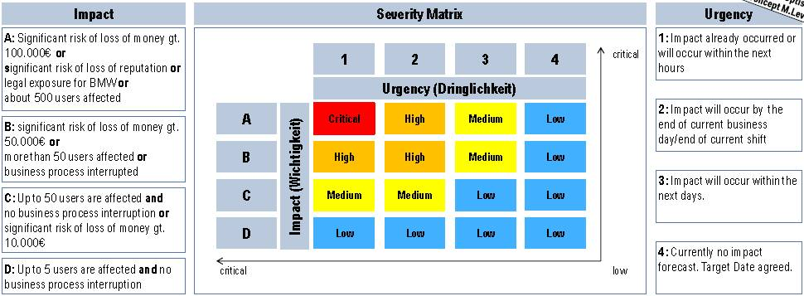

For China business the APAC/ Eastern Time zone apply. The table show the possibilities of service levels.

Service Level Parameter ever business process / Service-Cluster

|  |  |  |  |
| --- | --- | --- | --- |
| **ID** | **Service Times** | **Description** | **Period** |
| **1** | **Operation Time (Mo-Fr)** | Time where normal operation/ support will be provided. Including low and medium tickets. | 07:00-20:00 SIN/Beijing Time |
| **2** | **Extended Service (Sa-Su)** | Service for critical and high tickets only. | 08:00 – 19:00 SIN/Beijing Time |
| **3** | **Disaster Recovery Actions(Critical and High ticket)** | System breakdown and interruption. | 24*7*365 days a year |

Table Operation time

|  |  |  |
| --- | --- | --- |
| **Service Cluster 1 – 1** | | |
| **Parameter** | **Figure** | |
| **Service time** | **Primary Time Zone:** | **ID 1,2,3 in operation time table** |
| **Availability time** | 100% (Mo-Fr: 07:00 – 20:00 SN) | |
| **CSLP-Name** | **Service Level Target** | |
| **Solution time** | Agreed Solution time for reaction to user service requests:   |  |  |  | | --- | --- | --- | | **Priority** | **Issue Description** | **Solution time** | | Critical | Critical system issues causing the stoppage of key business operations | 1Hour | | High | Major system issues causing the partial stoppage or significant delay of key business operations | 4Hour | | Medium | Major issues impacting the key business operations without causing stoppage | 8 Hour | | Low | Minor system issues with insignificant impact on the key business operations | 33 Hour |   Agreed Solution time for System Interruption and Breakdown:  Since the VENDOR should have data backup plan for such incident, the service should be recovered within 1 Hour after breakdown. | |

#### Quality Assurance

Supplier should design or support designing test strategy with BMW project team: system test, integration test, UAT, performance test, penetration test, stability test, production test before go-live and other necessary test activities related with concerned system.

Write test case for product system test and integration test, support test case review for UAT test, and provide support to performance test, penetration test, stability test, production test before go-live and other necessary test activities related with concerned system.

#### Warranty

Application operation support warranty period: 6 month warranty period after the last sprint go-live

Trouble shooting and bug fix for free during the warranty period

#### Server hosting

Target system should be hosted internally at the BMW Group China Data Centre or BMW authorized data center, or can be deployed to BMW private cloud.

The vendor should supply the infrastructure solution.

The vendor should support for the infrastructure setup.

#### Business Continuity and Emergency Management

Supplier shall maintain a Business Continuity and Disaster Recovery Plan (BC/DRP), and implement such plan in the event of any unplanned interruption of the Services, through which Supplier will be able to perform its obligations (including service level agreements) with minimal disruptions or delays. Supplier agrees to deliver a copy of its executive summary of the BC/DRP for the Services upon request, and maintain and exercise the BC/DRP at regular intervals (no less frequently than annually), and will provide BMW AFC with documented results of the BC/DRP tests that relate to the Services provided. Supplier shall immediately notify BMW AFC of any disaster or other event in which the BC/DRP is activated.

In case of incident or emergency, escalation matrix is as below:

|  |  |  |
| --- | --- | --- |
| **Issues Unresolved for** | **Escalation Level** | **Contact Person** |
| 1 Day | IT Operation Manager | Peter.Han@BMW.com |
| 3 Days | IT Manager | Cathy.Chen@BMW.com |
| 5 Days | Senior Manager IT | Michael.MC.Conrad@bmw.de |

#### Security

Suppliers require to confirm compliance with the Company Policies, and strictly follow BMW security requirements.

Data security and protection is very important to BMW. Not only customer data, but all business related date is required to be secured with right and sufficient protection measurement from either technical or legal aspects. Please provide detail description about what data will be accessed, processed, stored by which modules in your whole solution, and in which area/domain this data will be processed or stored. If there’s any data protection approaches that will/can be taken in your solution, please also explain that. A clear infrastructure and architecture diagram with necessary information description is highly recommended.

#### Exit Services In Relation To Expiration or Termination

During the period between at least six (6) months before expiration or upon any BMW AFC notice of termination and the cessation of provision of all Services by Supplier (the “Disengagement Period”), the Parties will continue to perform all of their obligations until the end of the Disengagement Period.

The Parties will co-operate reasonably and in good faith so that the transition from the Services rendered under this contract shall be timely and efficient. Within ninety (90) days after a reasonable and proper request by BMW AFC, Supplier shall prepare and deliver to BMW AFC an Exit Plan summarising:

* The services to be provided by Supplier during the Disengagement Period;
* The term and manner in which the relevant Services are to be delivered;
* A summary of BMW AFC confidential information to be returned, if any, or destroy the same in accordance with the reasonable instructions given by BMW AFC;
* A summary of the equipment, documents, records, books, tapes, disks and files provided by BMW AFC to which BMW AFC retained title and which have not been disposed of with BMW AFC’s permission, shall be returned to BMW AFC in substantially the same condition as received, ordinary wear and tear excepted.

#### Quality Control

**Quality Control Introduction**

* The objective of quality control function is to ensure and continuously improve customers’ satisfaction.
* The main responsibilities include monitoring and measure quality performance, identify quality issues, and develop short term and long term actions to resolve issues and make continuous improvements.
* Here are some examples of quality controls that required by BMW AFC:
  + Review daily records
  + Review system availability
  + Review VENDOR processes and qualifications
  + Review quality and accuracy of the reports
  + Review VENDOR supporting services quality and speed of response.

**Quality Certifications**

BMW AFC will evaluate and encourage VENDOR to obtain and maintain relevant industry quality and information security certifications, such as ISO, ISCCC, PCI and etc.

#### Training

VENDOR shall provide necessary training to BMW AFC associates when applicable, either onsite or remote, regular or irregular based on business requirement from BMW AFC.

## Administration

**Confidentiality, return, copyright**

This Invitation to Tender (and all attachments) may only be made available to those areas of the company that are involved in the bidding. If a third party company is to take over part of this work then it is to be registered.



# Section 3: SERVICE AGREEMENT

## Commencement and Duration

This Agreement shall commence on 1st Jan, 2019 and shall continue for a period of 3 years unless terminated earlier in accordance with relating terms of this Agreement.

## Services

Subject to the issuance of a Purchase Order to the VENDOR, the VENDOR shall provide the Services, including the delivery of the Deliverables, in accordance with this Agreement.

The VENDOR shall:

* At all times during the continuance of the Agreement perform the Services faithfully and diligently, with all reasonable care and skill, in accordance with the Service Levels (if any), and in an efficient and timely manner;
* Assign Employees to the Services and be responsible and liable for the acts and omissions of the Employees;
* Use its own facilities and equipment to provide the Services. If there is any assigned third-party provider involved, then vendor shall be liable for the quality of service provided by this third-party provider.

## Performance

The parties shall meet at regular intervals to consider matters relating to the performance of the Services.

The VENDOR shall provide to BMW AFC written reports on the performance of the Services in accordance with this Agreement and such other reports as BMW AFC may from time to time reasonably request at no additional cost.

BMW AFC shall review the performance of the VENDOR on a monthly basis against the KPI or SLA, (if any).

## Compliance

The VENDOR warrants that:

* It has the right to supply the Services in accordance with this Agreement;
* It holds and shall retain throughout this Agreement all necessary consents required to fulfil its obligations under this Agreement, including without limitation all licenses, permits or similar permissions required to fulfil such obligations by local regulatory authorities in each jurisdiction where the Services are to be provided, and shall comply with the terms of all such consents;
* It shall comply with all laws, regulations and guidance which relate to the activities comprised in, or ancillary to, the Services; and
* The Services and the Deliverables do not and will not infringe the Intellectual Property Rights of any third party.

## ACTING FAIRLY

When carrying out any Services, the VENDOR shall act in good faith and in a professional, fair and courteous manner towards BMW AFC contact point and shall not act in any way, which may bring BMW AFC’s name or reputation into disrepute.

## Appendix

Please be noted all appendixes shall be regarded as the integral part of this RFQ and shall be remain the same effect as main content.

**GTC**

BMW expect that the selected supplier is accepting the GTC. Please let us know if you can accept them or which parts exactly you want to change.

Acceptance of BMW AFC GTC is mandatory to participate in the bidding.

If we have already aligned on GTC then have to follow as is instead of discussing again as part of AFC GTC.



**STC**

BMW expect that the selected supplier is accepting the STC. Please let us know if you can accept them or which parts exactly you want to change. If selected supplier has no concerns for STC mentioned above, STC need to be signed by onsite supplier personnel and chopped by supplier.



**DPA**

BMW expect that the selected supplier is accepting the DPA. Please let us know if you can accept them or which parts exactly you want to change. If selected supplier has no concerns for DPA mentioned above, DPA need to be signed by supplier personnel who will process BMW personal data and personnel supervisor then chopped by supplier.



DPA appendix

 

**Security policies**

Information Security Instruction



IT Security Regulation



### Quotation Template

